ANIMAL SHELTER APPLICATION

TECHNICAL SPECIFICATIONS

TEAM MEMBERS
Nistor Marius-Ionuț and Negru Briana-Maria

- USER REQUIREMENTS SPECIFICATION (INFORMAL)
For this particular application and documentation phase, we have chosen to use a document in natural language.

A.1 GENERAL DESCRIPTION
The main goal of this application is to facilitate and streamline the adoption process of stray animals. It serves as a bridge between adopters and shelter representatives, increasing the probability of abandoned pets finding their forever home. This is achieved through seamless communication and interaction.

A.2 REGISTRATION PROCESS FOR BOTH PARTIES INVOLVED
In order to register, users are required to provide a unique user name, a password and basic information. Registration is required before any further steps can be taken. Those wishing to register as adopters must provide a valid proof of identity and contact details, such as a telephone number or email address. To register as an employee, one must provide a shelter name and address, along with anything that can prove employment.

A.3 SHELTER REPRESENTATIVE
Upon logging in, a shelter representative is granted access to manage the animals available for adoption. They can add new animals, edit existing profiles, or remove animals that have been adopted. Each animal profile includes details such as name, age, gender, breed, description, backstory, and one or more photos.

Furthermore, shelter representatives can view a list of adoption requests received for the current day. The authority to approve, reject or waitlist adoption requests is held by the adoption team. They will provide reasons for rejection or schedule an interview to complete the adoption process.

A.4 ADOPTER
Once logged in, adopters can browse through a list of available animals for adoption. The list should be searchable by animal name, category, age, breed or location. Adopters can view detailed profiles of each animal, including photos and descriptions.

They can submit adoption requests for specific animals they are interested in. They can also track the status of said requests, whether they are approved, rejected, pending or completed. If a request is declined, the reason for rejection will be provided. If approved, possible interview appointments will be displayed.

A.5 CONCLUSION
Overall, this application aims to streamline the adoption process, making it easier for both shelters and adopters to connect and find loving homes for stray animals.

- USE CASE DIAGRAM (SEMI-FORMAL)

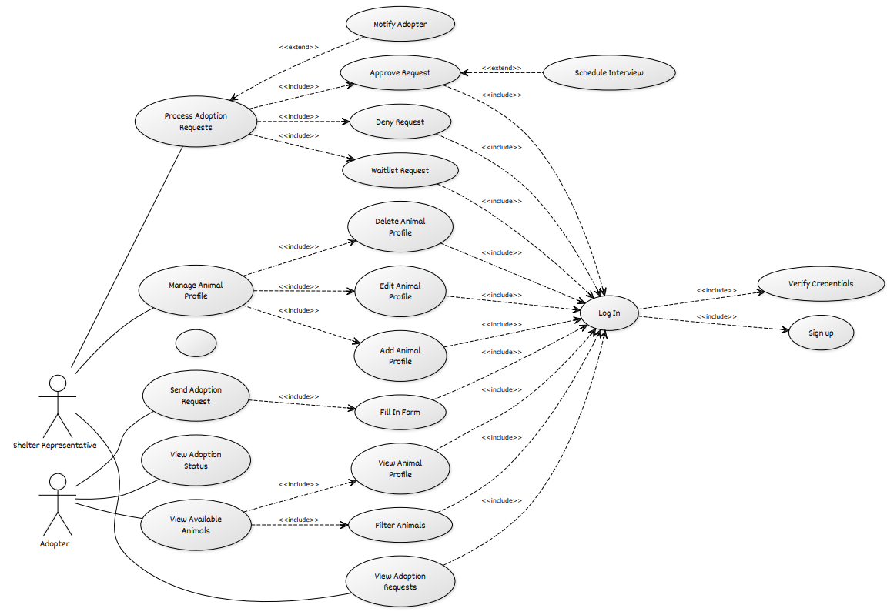

- SYSTEM REQUIREMENTS SPECIFICATION (FORMAL)
The Animal Shelter Application is a web-based platform that connects adopters with shelters, streamlining the pet adoption process through easy browsing, request submission, and status tracking.

C.1 SYSTEM ARCHITECTURE
Frontend: HTML, CSS, JavaScript (React.js)
Backend: Node.js with Express
Database: PostgreSQL / MongoDB ?
Authentication & Security: JWT authentication, bcrypt for password hashing ?
Hosting & Deployment: AWS / Firebase / Vercel / Heroku ?
Version Control: Git, GitHub/GitLab for collaborative development

C.2 FUNCTIONAL REQUIREMENTS

C.2.1 USER MANAGEMENT

REGISTRATION & AUTHENTICATION
Users must register before accessing application features.
Adopters provide proof of identity and contact details.
Shelter representatives provide shelter name, address, and proof of employment.
Secure authentication with hashed passwords.

USER ROLES
ADOPTER: Can browse available animals, submit adoption requests, track request status.
SHELTER REPRESENTATIVE: Can manage animal profiles, approve/reject adoption requests.

C.2.2 ANIMAL MANAGEMENT

CRUD OPERATIONS FOR ANIMAL PROFILES
Shelter representatives can add, update, and delete animal profiles.
Each profile contains:
MANDATORY FIELDS: Name, age, gender, breed, description, medical history.
OPTIONAL FIELDS: Backstory, special care instructions, multiple images.

SEARCH & FILTER FUNCTIONALITY
Search animals by name, category, breed, age, and location.
Filter based on availability (adopted/pending/available).

C.2.3 ADOPTION WORKFLOW

SUBMISSION OF ADOPTION REQUESTS
Adopters can submit requests for specific animals.
Requests contain user details, animal preference, and reason for adoption.

REQUEST TRACKING
Statuses: Pending, Approved, Rejected, Completed.
If rejected, a reason is provided.
If approved, adopter is notified of interview scheduling.

INTERVIEW SCHEDULING
Shelter representatives set up interview slots.
Adopters confirm appointment from their dashboard.

C.2.4 NOTIFICATIONS & MESSAGING ?

EMAIL/SMS NOTIFICATIONS FOR
Account verification
Adoption request updates
Interview scheduling confirmations
C.3 NON-FUNCTIONAL REQUIREMENTS

C.3.1 SCALABILITY
Cloud-based deployment to handle increasing user traffic.

C.3.2 SECURITY
Data encryption, input validation, role-based access control.

C.3.3 PERFORMANCE
Optimized database queries, lazy loading for images.

C.3.4 USABILITY
Responsive UI/UX for seamless navigation on mobile and desktop.

- DEVELOPMENT PLAN

D.1 WEEKLY BREAKDOWN

 | TASK | RESPONSIBILITIES
1 | INITIAL PLANNING & SETUP | Discuss requirements, choose technologies, set up Git repository
2 | BACKEND CONFIGURATION | Install Node.js & PostgreSQL, set up API
3 | DATABASE MODELING | Create entities (User, Animal, AdoptionRequest), test with JUnit and Mockito
4 | AUTHENTICATION & AUTHORIZATION | Implement JWT for login/logout, user roles management
5 | CRUD OPERATIONS FOR ANIMALS | API for adding, editing, deleting, and listing animals
6 | FRONTEND – INITIAL STRUCTURE | Set up React, create basic UI components
7 | BACKEND-FRONTEND INTEGRATION (ANIMALS) | Connect frontend to API for managing animals
8 | ADOPTION REQUEST SYSTEM | Implement API for handling adoption requests
9 | ADOPTION INTERFACE + API INTEGRATION | Forms and UI for adoption requests, status tracking
10 | NOTIFICATION SYSTEM | Implement email notifications for adoption status updates
11 | TESTING & OPTIMIZATION | Debugging, unit and functional testing
12 | ADDITIONAL FEATURES | Filtering animals, adoption statistics, UI improvements
13 | FINAL TESTING & DOCUMENTATION | Complete testing, finish documentation for users and developers
14 | PRESENTATION & FEEDBACK | Prepare demo, final adjustments, project delivery

TASK | BRIANA | MARIUS
PROJECT SETUP | X | X
BACKEND API | X | X
DATABASE MODELING | X | X
FRONTEND UI | X | X
AUTHENTICATION & AUTHORIZATION | X
ANIMAL MANAGEMENT | X
ADOPTION REQUEST MANAGEMENT |  | X
EMAIL NOTIFICATIONS |  | X
TESTING & DEBUGGING | X | X
DOCUMENTATION & PRESENTATION | X | X

NOTES

WEEKS 1-4 → Focus on backend and database
WEEKS 5-7 → Build user interface
WEEKS 8-10 → Integrate adoption requests and notifications
WEEKS 11-14 → Testing, improvements, and presentation preparation

